**Non photorealistic rendering with tile based deferred shading on WebGL**

Sijie Tian, Yuqin Shao

**Overview**

Deferred shading, a screen-space shading technique, which enables fast and complex light resource management, has been more and more widely used in game industry. However, it seems this technique has much less use on WebGL.

In this project, we are trying to implement an advanced deferred shader on WebGL as well as to achieve some non-photorealistic rendering effects. Besides, in order to accelerate the whole process, we plan to implement the tile based deferred shading. Having these features, we can make games like Borderland on Web.

**References**

Some non-photorealistic effects we are trying to implement <http://www.bongiovi.tw/experiments/webgl/blossom/>

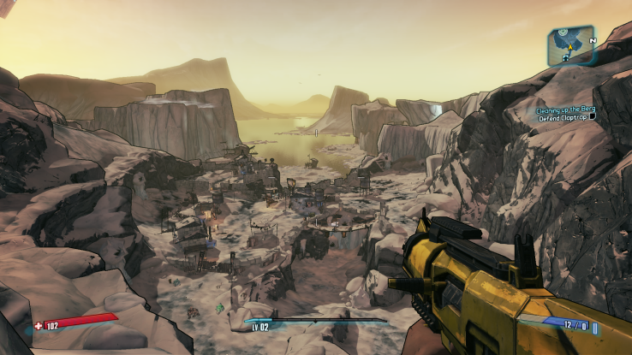

Borderland 2

A demo of webgl deferred shading

<http://codeflow.org/entries/2012/aug/25/webgl-deferred-irradiance-volumes/#!>

Tile based deferred shading

<http://visual-computing.intel-research.net/art/publications/deferred_rendering/>

[http://bps10.idav.ucdavis.edu/talks/12-lauritzen_DeferredShading_BPS_SIGGRAPH2010_Notes.pd](http://bps10.idav.ucdavis.edu/talks/12-lauritzen_DeferredShading_BPS_SIGGRAPH2010_Notes.pdf)